“Trust in the LORD”
October 4, 2015
Proverbs 3:1-10
Please take your Bible in hand and open it to the Book of Proverbs at chapter three. Have you ever wondered why all of our US currency has this phrase on it “In God we trust”?
The first time our US coins had “In God we trust” on them was during the second term of President Ulysses S. Grant. And the reason is came to be was this. A Pastor from Ridleyville, PA., Rev. M. R. Watkinson, wrote to the secretary of the treasury requesting that we put a clear reference to God on our coins so we would always be reminded that our nation is not a heathen nation. The secretary of the treasury responded to his letter by writing this to the Director of the Mint in Philadelphia. “No nation can be strong except in the strength of God, or safe except in His defense. The trust of our people in God should be declared on our national coins.” That was February 12, 1873.
Then, we had to wait until July 30, 1956 for our U.S. Congress to submit a bill to President Dwight D. Eisen-hower which He then signed into law that all or our U.S. paper currency should have on it this phrase “In God We Trust.”
Now, it’s one thing to have these words inscribed on our coins or to carry a copy of it on the dollar bills we have in our purses or wallets. It’s quite another to live daily with the sense that we really do obey the LORD’s command to trust in Him.
It was the day before his fifty-second birthday, February 11, 1860. Abraham Lincoln was leaving Springfield, IL for the White House to become our sixteenth President. Little did he know that less than five years later he would be assassinated. As Lincoln stood before his friends and family on the railway platform that day, he said this.
“I now leave not knowing when, or whether ever, I may return, with a task before me greater than that which rested upon [George] Washington. Without the assistance of the Divine Being who ever attended him, I cannot succeed. With that assistance, I cannot fail.
Trusting in Him who can go with me, and remain with you, and be everywhere for good, let us confidently hope that all will yet be well. To His care commending you, as I hope in your prayers you will commend me. I bid you an affectionate farewell.”
Trust is an everyday word. It’s a common word; but is it a common thing for you to trust in the LORD with all your heart all day long?
Here’s what you’ll find in one of the most well-known passages in your Bible. Proverbs 3:5-6 “Trust in the LORD with all thine heart, and lean not on thine own understanding; (6) In all thy ways acknowledge Him, and He shall direct thy paths.”
I’ve titled today’s sermon “Trust in the LORD.” Shall we pray?
Trust. This was a Bible term long before it became a popular word in the English language. It was the Holy Spirit Who moved Solomon to write this word. The Hebrew חטַבָּ (pronounced batah) has a very interesting meaning. It means “to throw one down upon his face,” “to lie extended upon the ground,” and also “to be confident.”
Imagine, if you can, being so aware of someone’s authority that you would physically and literally “throw yourself to the ground in front of them.”
Can you remember a time in your life when you felt so overwhelmed by the LORD or by His presence that you simply fell down before Him? He’s a majestic king! He’s a Sovereign! He’s LORD of all! He’s the highest of the highest of kings!
So, yes, He’s worthy of your whole-hearted trust. And shouldn’t you “throw yourself down upon your face before Him”? Trust, you see, does mean confidence. But it implies that the one you are trusting is much, much larger than you.
Here’s King David in Psalm 28. Psalm 28:7 “The Lord is my strength and my shield; my heart trusted in him, and I am helped: therefore my heart greatly rejoiceth; and with my song will I praise him.”
So, trust isn’t a word that any of us should use lightly. Now, note, you’ve likely said “I don’t trust him” or “I don’t trust her.” That’s because you know what you don’t want to do. Now you might also say that because you trusted that person and that person abused your trust. But, it’s almost a natural thing to trust someone’s word the first time you meet them.
A young man I know recently found a truck on Craigslist that he thought he might want to buy. So, he calls and sets up an appointment to see it. But when he go there, he immediately saw that the picture he’d seen on Craigslist didn’t show the truth about the truck. It had been in an accident. It had some serious transmission problems. And it needed a lot of work.
Now, what is your trust level now that you’ve seen the truck and taken it for a drive? You have little or no confi-dence in the seller because the vehicle was nothing like it appeared on craigslist.
What’s on my heart today is this. Trusting God is the one thing that will enable you to sense God’s clear direction.
Look at these three things.
One, trust in the LORD with all your heart.
Two, lean not onto your own understanding.
And three, in all thy ways, acknowledge Him.
And – He shall direct your paths.
The LORD’s direction appears when you’ve put three things into operation: one, trust in Him; two, no more leaning on your own understanding, and three, recognizing and acknowledging Him in all the areas of your life.
So, first, can you whole-heartedly trust the LORD? He’s worthy of your whole-hearted trust.
You might be among those who think that you trust God when things go from bad to worse; when a serious problem arises in your life. But here’s the truth. If you only trust the LORD when you are hurting or when your financial picture had turned south or when you are out of work or things didn’t go as you’d hoped, then you really aren’t trusting the LORD.
Let’s say you encounter a problem at work and you begin to allow yourself to get agitated and frazzled and worried. And then, out of anxiety and fear, you begin to pray. No, that’s not trust. If you did that, you can compare yourself to the man who sees God as his genie in a bottle. Whenever you summon the genie, he appears and says “Your wish is my command.”
God doesn’t work that way.
Here’s His way. You trust Him whole-heartedly today. You have confidence today that He’s working everything together for good on your behalf. And here’s why. When you trust God every day and trust Him as a child would trust his father, then, when things don’t go as you planned, you won’t sulk and turn away from him. Instead, you’ll know that He’d never allow you to pass through those waters, sometimes deep waters, unless it was for your good.
Isaiah 43:2 “When thou passest through the waters, I will be with thee; and through the rivers, they shall not overflow thee: when thou walkest through the fire, thou shalt not be burned; neither shall the flame kindle upon thee.”
Do you really want to know what “whole-hearted trust” is? It’s full surrender today because you’ve got today. You’ve got Him today. You’ve got His promise today. You aren’t guaranteed tomorrow. It’s full surrender today because He’s promised to supply all your needs – today.
If you aren’t fully surrendered to Him today, what makes you think that you will fully trust Him when the storm comes to your house?
Each day this week you can do this. Ask the LORD to teach you to trust Him with all your heart. He’ll help you. He’ll watch over you like a mother bird watching over her baby birds. He’s a Heavenly Father Who sees every little thing that comes into your life.
And when sorrow comes your way; when He allows a trial or some affliction, your heart will already be confident in Him. You will know that He will not fail you. He’s ever-present and He’s ever-able to do exceeding abundant above all that you ask or think.
So, this week, read, believe, meditate on what He says. Let your Bible dwell in your richly each day this week.
First, you can trust the LORD whole-heartedly.
Second, you can stop leaning on your own understanding.
Now, aren’t there lots of Scriptures that command us to seek after understanding?
Here’s one. Here’s Proverbs chapter two. Proverbs 2:1 “My son, if thou wilt receive my words, and hide my commandments with thee; (2) So that thou incline thine ear unto wisdom, and apply thine heart to understanding; (3) Yea, if thou criest after knowledge, and liftest up thy voice for understanding;
(4) If thou seekest her as silver, and searchest for her as for hid treasures; (5) Then shalt thou understand the fear of the Lord, and find the knowledge of God. (6) For the Lord giveth wisdom: out of his mouth cometh knowledge and understanding.”
But can you see the difference? The understanding referred to here in Proverbs two is the understanding that comes from the heart and mind of the LORD.
Over here in Proverbs 3:5-6, we find this “Lean not unto your own understanding.” How often have your I looked for understanding that is apart from the LORD?
Now, why?? Why stop leaning on your own understand-ing? One big reason: because your Big God sees the big picture of your life.
And what is “your own understanding”? Simply put, it’s drawing conclusions based primarily upon our perceptions. It’s leaving God out of our daily equations.”
Our understanding is not naturally His.
Isaiah 55:8 “For my thoughts are not your thoughts, neither are your ways my ways, saith the LORD. (9) For as the heavens are higher than the earth, so are my ways higher than your ways, and my thoughts than your thoughts.”
So, simply put, we don’t naturally think God’s thoughts. Instead, we naturally lean on our own understanding.
And to “lean” like this on your own understanding is a sin. It’s really an affront to God. When you lean on your own understanding and when you refuse to lean on His under-standing, you’ve placed yourself ahead of Him; above Him. You think you know better than Him.
Now, what does “lean” mean? “Lean” [שָׁעַן] means “to support yourself with,” and “to rely on.”
Reliability and support are things that matter every single day. Now, think about someone that you’ve relied on and then they became unreliable. Maybe it was a boss or, let’s say, a company that you’ve worked for for many years. Now, they’ve handed you a pink slip. What happens to you? You are hurt. You relied on them and they failed you. That’s what happens when we lean on our own understanding. You see, your understanding is only partial understanding. It’s not reliable. You can’t lean on or support your life with your own understanding.
And yes, you did work hard. You were faithful. Yet, who were you relying on? Wouldn’t it have been far better to know that each day as you went to work, you had relied upon the LORD? Wouldn’t it be much better to go to work with the understanding that He’s the One Who supplied your position? He’s the One Who gives you the health and the strength and the wisdom and the ability to do your job.
And, practically speaking, is there anything in this world that is truly reliable? When it comes to people, your income, your job, even your insurance company; God knows that your safest reliability is Himself.
So, He recorded this in your Bible. “But my God shall supply all your need.” “He is able to do exceeding abundantly above all that you ask or think.” “He’s able to make all grace abound toward you so that you, always having all sufficiency, may abound to every good work.”
And that leads me to this very important thing. Are you searching the Scriptures daily, looking to God for His understanding? Whose word in this world is reliable? When will you come to rely on His promises instead of your ideas? When will you believe that He is sovereign over your life? When will you come to have confidence in Someone Who is right now involved in your life and Who is teaching you not self-dependence, but God-dependence?
This is a true story. It’s from a book called “The Heavenly Man” by Brother Yun, one of the many persecuted Pastors in China. He tells in the book that he had to face weeks of torture, including electrocution, starvation, beat-ings, and having needles shoved under his fingernails. He was then thrown in a cell, actually a box, just four feet long, three feet wide, and four feet high; where he was to stay indefinitely. The day after he was put in this mini cell, he felt prompted to pray for a Bible — a ridiculous idea, consider-ing that many people were in prison at that very moment for being in possession of such contraband. Yet he prayed any-way. And, inexplicably, the guards threw a Bible into his cell the next morning.
Here’s Brother Yun’s words. “I knelt down and wept, thanking the Lord for this great gift. I could scarcely believe my dream had come true! No prisoner was ever allowed to have a Bible or any Christian literature, yet, strangely, God provided a Bible for me! Through this incident the Lord showed me that regardless of men’s evil plans for me, he had not forgotten me and was in control of my life.”
And what had Brother Yun been learning? That suffering is not outside God’s understanding. Nor is it outside His sovereign control. He’s LORD. And He’s taken on the responsibility to get you to lean not on your own under-standing, but rather, His.
Haven’t there been times in your life when you felt someone mistreated or short-changed you; someone cheated you; someone persecuted you? And your response told you this. Either you were relying upon His understanding or on your understanding.
So, what is it that you are facing today that calls for understanding; but you are still relying upon your own?
Folks, the LORD is patient and faithful? You might be leaning on your own understanding today. You might have a situation at home or at work that you are frustrated with or irritated by or, in some cases, just plain sick of.
But the LORD, even in those things you are right now going through, is training you in learning to choose to be supported by His understanding; to stop leaning on your own understanding.
So, you need to look to His word daily. And you also need to wait patiently for the voice of the LORD.
First, you can trust the LORD whole-heartedly.
Second, you can stop leaning on your own understanding.
Third, in all your ways, acknowledge Him.
What does this word mean?
One, it means that you and I are to recognize the LORD’s hand upon our lives.
Two, it means you and I are to recognize His authority over our lives.
Three, it means you and I are to wholly submit to Him.
Fourth, it means we are to seek His will in everything: every decision, every problem we encounter, every mundane thing.
Folks, the LORD is as close as your breath. He sees your life. He knows your needs. He cannot forget or fail you.
And what is He looking for from you? That you would acknowledge Him in all your ways.
Here’s a poem titled “Move on over God.” It was written by Willie Julie Tabb. See if it doesn’t sound a bit like you and me.

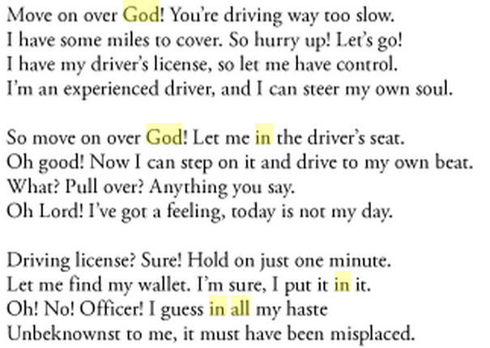

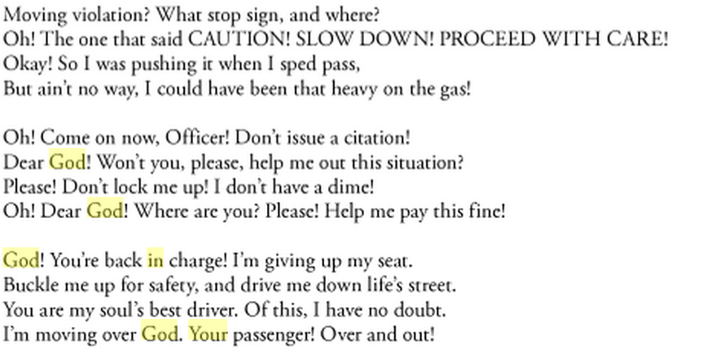

First, then, you can trust the LORD whole-heartedly.
Second, you can stop leaning on your own understanding.
Third, in all your ways, acknowledge Him.
Finally, God promises to control your destiny.
Isaiah 12:2 “Behold, God is my salvation; I will trust, and not be afraid: for the Lord Jehovah is my strength and my song; he also is become my salvation.”
Psalm 32:8 “I will instruct thee and teach thee in the way which thou shalt go: I will guide thee with mine eye.”
Psalm 25:4 “Shew me thy ways, O Lord; teach me thy paths. (5) Lead me in thy truth, and teach me: for thou art the God of my salvation; on thee do I wait all the day.”
Proverbs 3:5-6 “Trust in the LORD with all thine heart, and lean not on thine own understanding; (6) In all thy ways acknowledge Him, and He shall direct thy paths.”
Can you see God’s clear promise to direct both your todays and your tomorrows? God wants for us for walk in His will because He knows that His will is always what’s best for us. He sees the full end from the full beginning. He’s the Alpha and the Omega.
So, what will you do this week? What will you do today? Will you turn to Him in full faith and say “LORD, I am right now trusting you with my whole heart. I’ve stopped leaning on my own understanding. I’m acknowledging you in all my ways. LORD, lead me into your paths.”
This is God’s word. It’s plain. It’s direct. It’s what you need. Will you abide in His word today? If you don’t do it today, you won’t likely do it tomorrow. Pray this pray today.
And finally, a word to those who have never put their trust in Jesus Christ.
The greatest need in every heart and the largest problem in every life is your sin and the fact that your sin is what separates you from God. The Prophet Isaiah said. “But your iniquities have separated between you and your God, and your sins have hid his face from you, that he will not hear.”
Yet, out of love, Jesus became the Substitute for your sins.
The Apostle Paul in the Book of Romans says this. Romans 3:23 “For all have sinned, and come short of the glory of God” and (Romans 6:23) “For the wages of sin is death; but the gift of God is eternal life through Jesus Christ our Lord.”
There’s only one way to receive God’s Salvation. It’s through God’s Son. And here’s how. The Bible says Acts 20:21 “… repentance toward God, and faith toward our Lord Jesus Christ.”
Will you repent and exercise faith towards Him?
Today is the day of Salvation? What will you do about the condition of your heart for eternity?
REPENT - “Will you change your mind about God, Christ, your sin, and God’s free gift of salvation?”
BELIEVE - “Will you simply trust Jesus Christ alone as the One Who paid the entire penalty for your sins?”
Here’s a simple salvation prayer for you to pray if you’ve never trusted the LORD for His free gift of eternal life. Salvation Prayer
- “LORD, I admit that I am a sinner and in need of your grace. I believe that You sent Your Son to the Cross to die for me. Please forgive me of all my sins and make me Your child. Thank you.”
Everyone who calls upon the Name of the LORD will be saved.
Now please turn with me to Hymn # 620 “Under His Wings”

